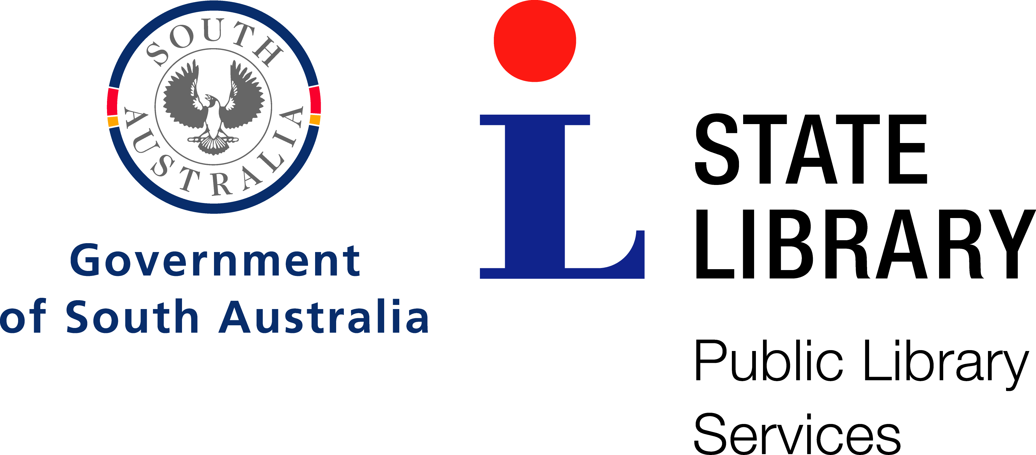

Community Languages Operating Committee meeting

Date: | Friday, 07 February 2014
Time: | 2:30pm
Location: | Public Library Services
Minute Taker:

- Welcome & Apologies

Network Attendees Chris Holles (City of Charles Sturt), Wendy Stacy (Marion), Tina Zollo (Campbelltown), Mary Ambrosi (Norwood, Payneham and St Peters), Janice Curtis (Pt. Adelaide/Enfield), Joy Smith (Burnside), Anne Pascoe (West Torrens)

PLS: Chris Kennedy

Apologies: Bill Roche (PAE), Bernie McSwain (Salisbury), Catherine Stephens (Unley), Helen Walkden (Onkaparinga), Wendy Abraham (Salisbury), Tamara Williams (Campbelltown)

- Business Arising and Minutes of Previous meeting

The 13th December 2013 meeting was solely a review of the Draft Community Languages Strategic Plan attended by both Operating Committee and Steering Committee members.

- Migrant Resource Centre.

Mirsia Bunjaka from the Migrant Resource Centre South Australia attended the first part of the meeting. Migrant Resource Centre is the main settlement agency for SA. MRCSA recognize the benefits of having local public libraries working with them to introduce new arrivals to the services that libraries can offer. Most recent arrivals are from Afghanistan, Burma, Bhutan, Middle East and Africa. The main cohorts settling in Mt Gambier are Congolese and Karen Burmese. The management team in Mt Gambier are Fernanda Ikeda (Fernanda@mrcsa.com.au) and Angela Malpas (angela.mrcsa@gmail.com)

The numbers arriving have reduced from approximately 2,000 in 2012 to between 1,300-1,500 expected in 2014.

Mirsia or another representative from MRCSA will attend CL Operating Meetings when possible to help keep libraries informed about how our community is growing and changing.

- Burnside Website

Burnside joined the LMS in Mid-February. Their Enterprise page was demonstrated. Access to advanced searches for specific languages has been built into links to facilitate easier searching.

- Community languages strategic planning, future directions
Ad Hoc sharing of CL stock was reported by libraries with stock being distributed to Coober Pedy, Pt Lincoln and Mt Gambier.
Suggested changes to the draft Community Language Strategic Plan were recommended and email approval to be sought before Chris Kennedy to be send the completed strategy to the PLSA executive.
The Strategic Plan proposed a working party to look at stock sharing, the policy document and the procedures document. Also for discussion would be the merit of the Alpha numeric language code, and the process for distributing material proportionately to libraries.

- Working Party
A working party comprising Caroline Bates, Joy Smith, Pauline Stephens, Katherine Hajdu, Hanna Jasinska, Tina Zollo, Chris Holles and Shirley Mauger will meet on April 4th to prepare the spending recommendation for 2014-15

- Other business
Teleconference access to Community Languages meeting requested for future meetings to allow sharing across the state.
Harmony Day
Katherine Hajdu recommended that library staff visit the Harmony Day link and register early to plan events for Harmony Day. www.harmony.gov.au
Merchandising material, badges are available.
No network events for Harmony Day 2014 were proposed.
Salisbury have scheduled 2 Little India sessions.
The next Community Languages Focus Group will be hosted by Norwood, Payneham and St Peters for the Italian community on February 22.

Next Meeting: 9:30 am May 2nd Friday 2014 at PLS

